**Food By Foodies**

**Introduction**

Food by Foodies is basically an android application. This application is having 3 type users. One is Admin, second is critic and the last one is user itself. This application is providing details of restaurants and Food Stalls. User will check for Restaurants and Food Stalls.

There are following activities in this application.

* Registration Page
* Login Page
* Restaurant Page
* Food Stall Page
* Add Restaurants Page
* Add Food Stall Page
* Logout
* View Profile

We will discuss these in details later.

**Responsibilities**

* **Admin**

The responsibilities of the admin are as follows,

* + Add Restaurants
  + Add Food Stalls
  + View Restaurants
  + View Food Stalls
  + View Profile
  + Logout
* **Critic**

Following are the responsibilities of Critic

* + Post Reviews on Restaurants
  + View Restaurants
  + View Food Stalls
  + View Profile
  + Logout
* **Users**

Following are the responsibilities of Users.

* View Reviews on Restaurants
* View Restaurants
* View Food Stalls
* View Profile
* Logout

**User Case Diagrams**

* **Login**

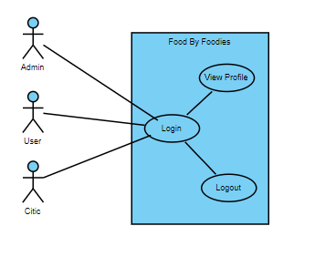

* **Admin Panel**

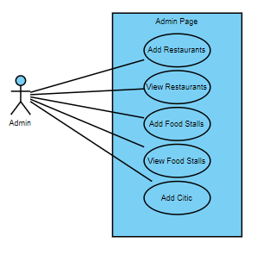

* **User Panel**

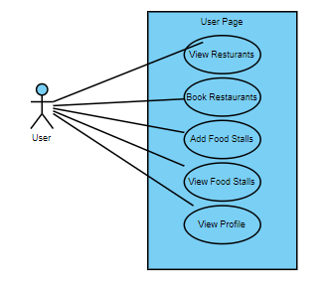

* **Citic Panel**

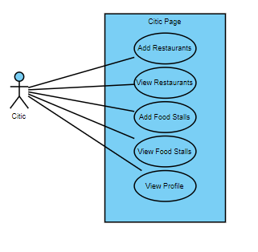

**Class Diagrams**

* **Admin Dashboard**

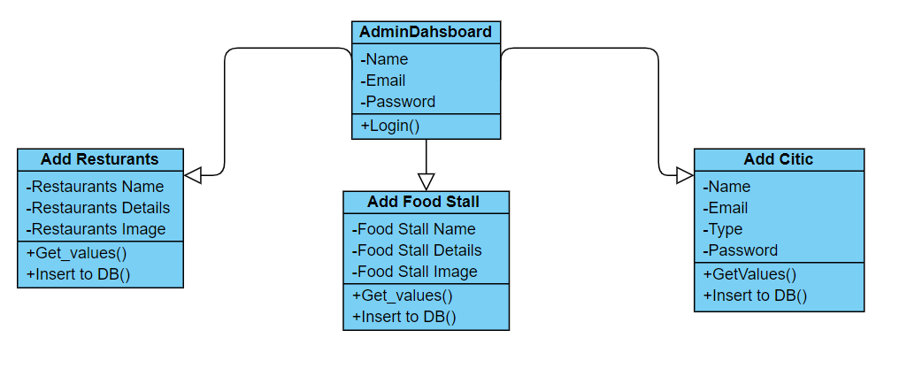

* **User Dashboard**

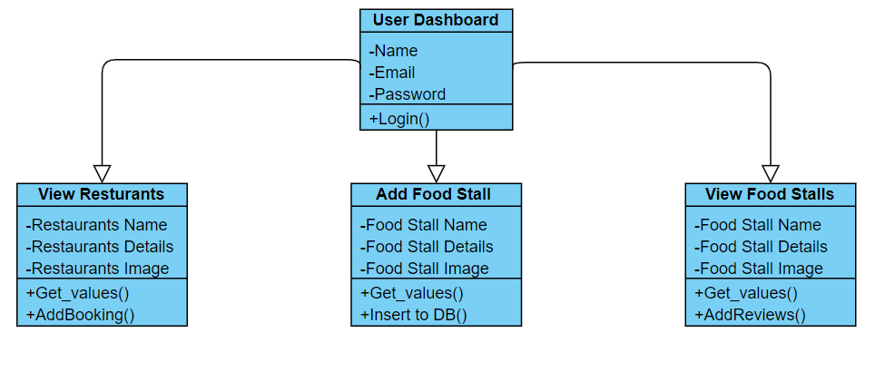

* **Critic** **Dashboard**

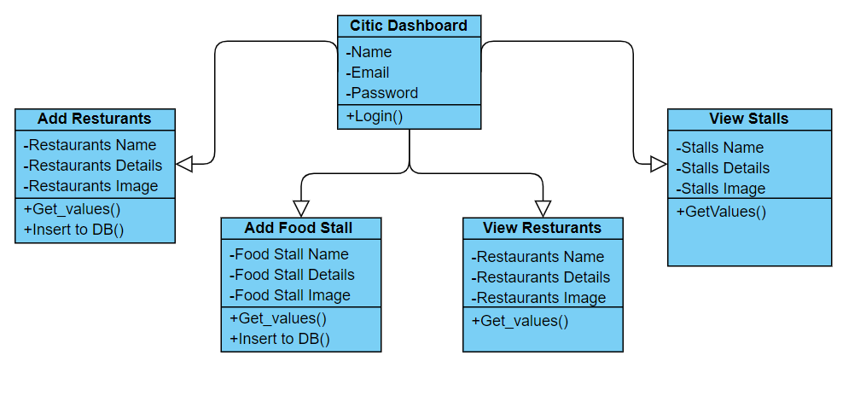

**Working of Application Activities**

* **Signup Activity**

This is the first activity where the user or admin can register itself. The Signup Activity contains following fields;

1. Name
2. Email
3. Surname
4. Password
5. Image uploading
6. Submit Button

All fields must be filled before pressing the button submit. We have also enabled the checks for these issues. Password should contain 8 or greater than 8 characters length. Email should be valid this check also works fine. Image uploading time depends on internet speed.

* **Login Activity**

This is the activity where the user or admin or critic can login itself. The Login Activity contains following fields;

1. Email
2. Password
3. Login Button

All fields must be filled before pressing the button Login. We have also enabled the checks for these issues. Password should contain 8 or greater than 8 characters length. Email should be valid this check also works fine. All data is checked for database firebase and if the user exists it will do to dashboard of respective types of users like admin will go to admin dashboard and so on.

* **Admin Dashboard**

Admin Dashboard is the main activity for user having type “Admin”. The Admin Dashboard contains following actions,

1. Add Restaurants
2. Add Food Stalls
3. View Stalls
4. View Restaurants
5. Add critic Type User
6. Update Profile
7. Logout

These above are the actions which can be performed by user type “Admin”. The roles of all three users like critic, User, Admin are different. We will discuss it in details.

* **Critic Dashboard**

Critic basically is Critics who cannot register it self using signup page because there is no such type Critics in signup page. But the Admin can add Critics to database just to help admin in their responsibilities. So that’s why admin dashboard has add Critics action to add Critics.

Critics has following actions to do,

1. Add Restaurants
2. Add Food Stalls
3. View Stalls
4. View Restaurants
5. Update Profile
6. Logout

Only Critics cannot add Critics to database but has full access to responsibilities of the admin. Like add Restaurants, add Stalls etc.

* **User Dashboard**

User dashboard is for the simple user whose type is “User” in database. User has less action in dashboard. The following are the actions that can perform user are,

1. View Stalls
2. View Restaurants
3. Update Profile
4. Logout

User can only View Food Stalls, View Restaurants, Update Profile and Logout.

* **Add Restaurants**

Add Restaurant is the activity where admin or critic can add restaurants which contains the Name of Restaurant, Details of Restaurants and Image of the Restaurants. Admin or Critic can add the restaurants by clicking the button of add restaurants from the dashboard.

The Add restaurants contains the following fields to be filled to add restaurants.

1. Title
2. Details
3. Image
4. Submit

* **Add Food Stalls**

Add Stalls is the activity where admin or critic can add stalls which contains the Name of Food Stall, Details of Food Stalls and Image of the Food Stalls. Admin or Critic can add the Food Stalls by clicking the button of add Food Stalls from the dashboard.

The Add Food Stalls contains the following fields to be filled to add Food Stalls.

1. Title
2. Details
3. Image

* **View Restaurants**

View Restaurants is the action can be applied by any type of user logged in. Means user, admin and critics can see restaurants by clicking button of view restaurants from dashboard. The User has the only two actions in dashboard rather than update profile and logout these are view restaurants and view food stalls.

Inside the View Restaurants we can get list of restaurants which are added by the admin or critics. When user clicks on any one another activity will be opened that contains Image details and title of the restaurants and at the last of the page a button is there to book the restaurant room. When you click on “Book” button it will open new activity with calendar view where you need to pick a date on which you want room and then when you will click on Book button it will redirects you to the OpenTable with date specified by user and displays every restaurant.

* **View Food Stalls**

View Food Stalls is the action can be applied by any type of user logged in. Means user, admin and critics can see Food Stalls by clicking button of view Food Stalls from dashboard. The User has the only two actions in dashboard rather than update profile and logout these are view restaurants and view food stalls.

Inside the View Food Stalls we can get list of Food Stalls which are added by the admin or critics. When user clicks on any one another activity will be opened that contains Image details and title of the restaurants.

* **Update Profile**

Update Profile activity is common in every type of users. Because we are only updating names, email and password. So the UpdateProfile.java activity contains the code of the updating record. User, Admin and critics can update their profiles by clicking on update profile button from dashboard. The code will be executed and get the name, email, password and image of the user to update profile activity and user can change and click on update button to update the records.

* **Logout**

Logout activity is also same as the update profile activity. It will logout the user from application.

* **Add Critics**

Add critics activity is only for the admin type user because critics can not register itself using registration activity because there is no such type “Critics”. So the admin has the authority to add critics to database for his help. Critics is just like the moderator of the application.